Task 5: Evidence Preservation and Analysis

- Forensic Activity Summary:
The objective of this task was to perform live forensic acquisition on a suspected compromised host (Server-Y / Windows 11 ARM) using Velociraptor for volatile data and triage collection. Due to the host's ARM64 architecture, traditional x64 kernel drivers for memory acquisition (WinPmem) were supplemented with high-frequency triage artifacts to ensure data integrity without system instability.

2.The Workflow
Followed a standard forensic procedure to ensure the evidence would hold up under security:
• Setup: We prepared a dedicated forensics folder at C:\Forensics to act as our secure storage for all captured items.
• Logical Imaging: Using FTK Imager, we created a logical image of the \Users\Public directory. This allowed us to package the suspicious files and their metadata into a forensic container.
• Network Capture: We used Velociraptor to pull live network artifacts (Netstat), giving us a clear view of active connections and ports at the time of the incident.
• Hashing & Verification: To guarantee that the data didn't change during the move, we used built-in verification tools to generate MD5 and SHA1 hashes. I then used PowerShell to generate a SHA256 hash for the final report.

3. Evidence Acquisition & Pivot

Analyst Note: During the acquisition phase, it was noted that the target system is running Windows 11 on ARM. Standard memory acquisition artifacts utilizing the winpmem driver are incompatible with the ARM64 kernel.
Resolution: To maintain forensic readiness, I pivoted to a KAPE (Kroll Artifact Parser and Extractor) collection via Velociraptor. This provided a comprehensive "triage" image including Prefetch files, Event Logs, and MFT data, which serves as a viable alternative for memory-resident threat analysis when full RAM dumping is technically restricted.

4. Chain of Custody & Evidence Documentation

This table maintains the integrity of the evidence by documenting the exact state of the files at the time of collection.
Step | Tool | Action | Status
Data Collection | FTK Imager | Imaged \Users\Public | Success
Integrity Check | FTK Imager | MD5/SHA1 Verification | Matched
Network Audit | Velociraptor | Netstat Artifact Pull | Completed
Final Hashing | PowerShell | SHA256 Generation | Verified

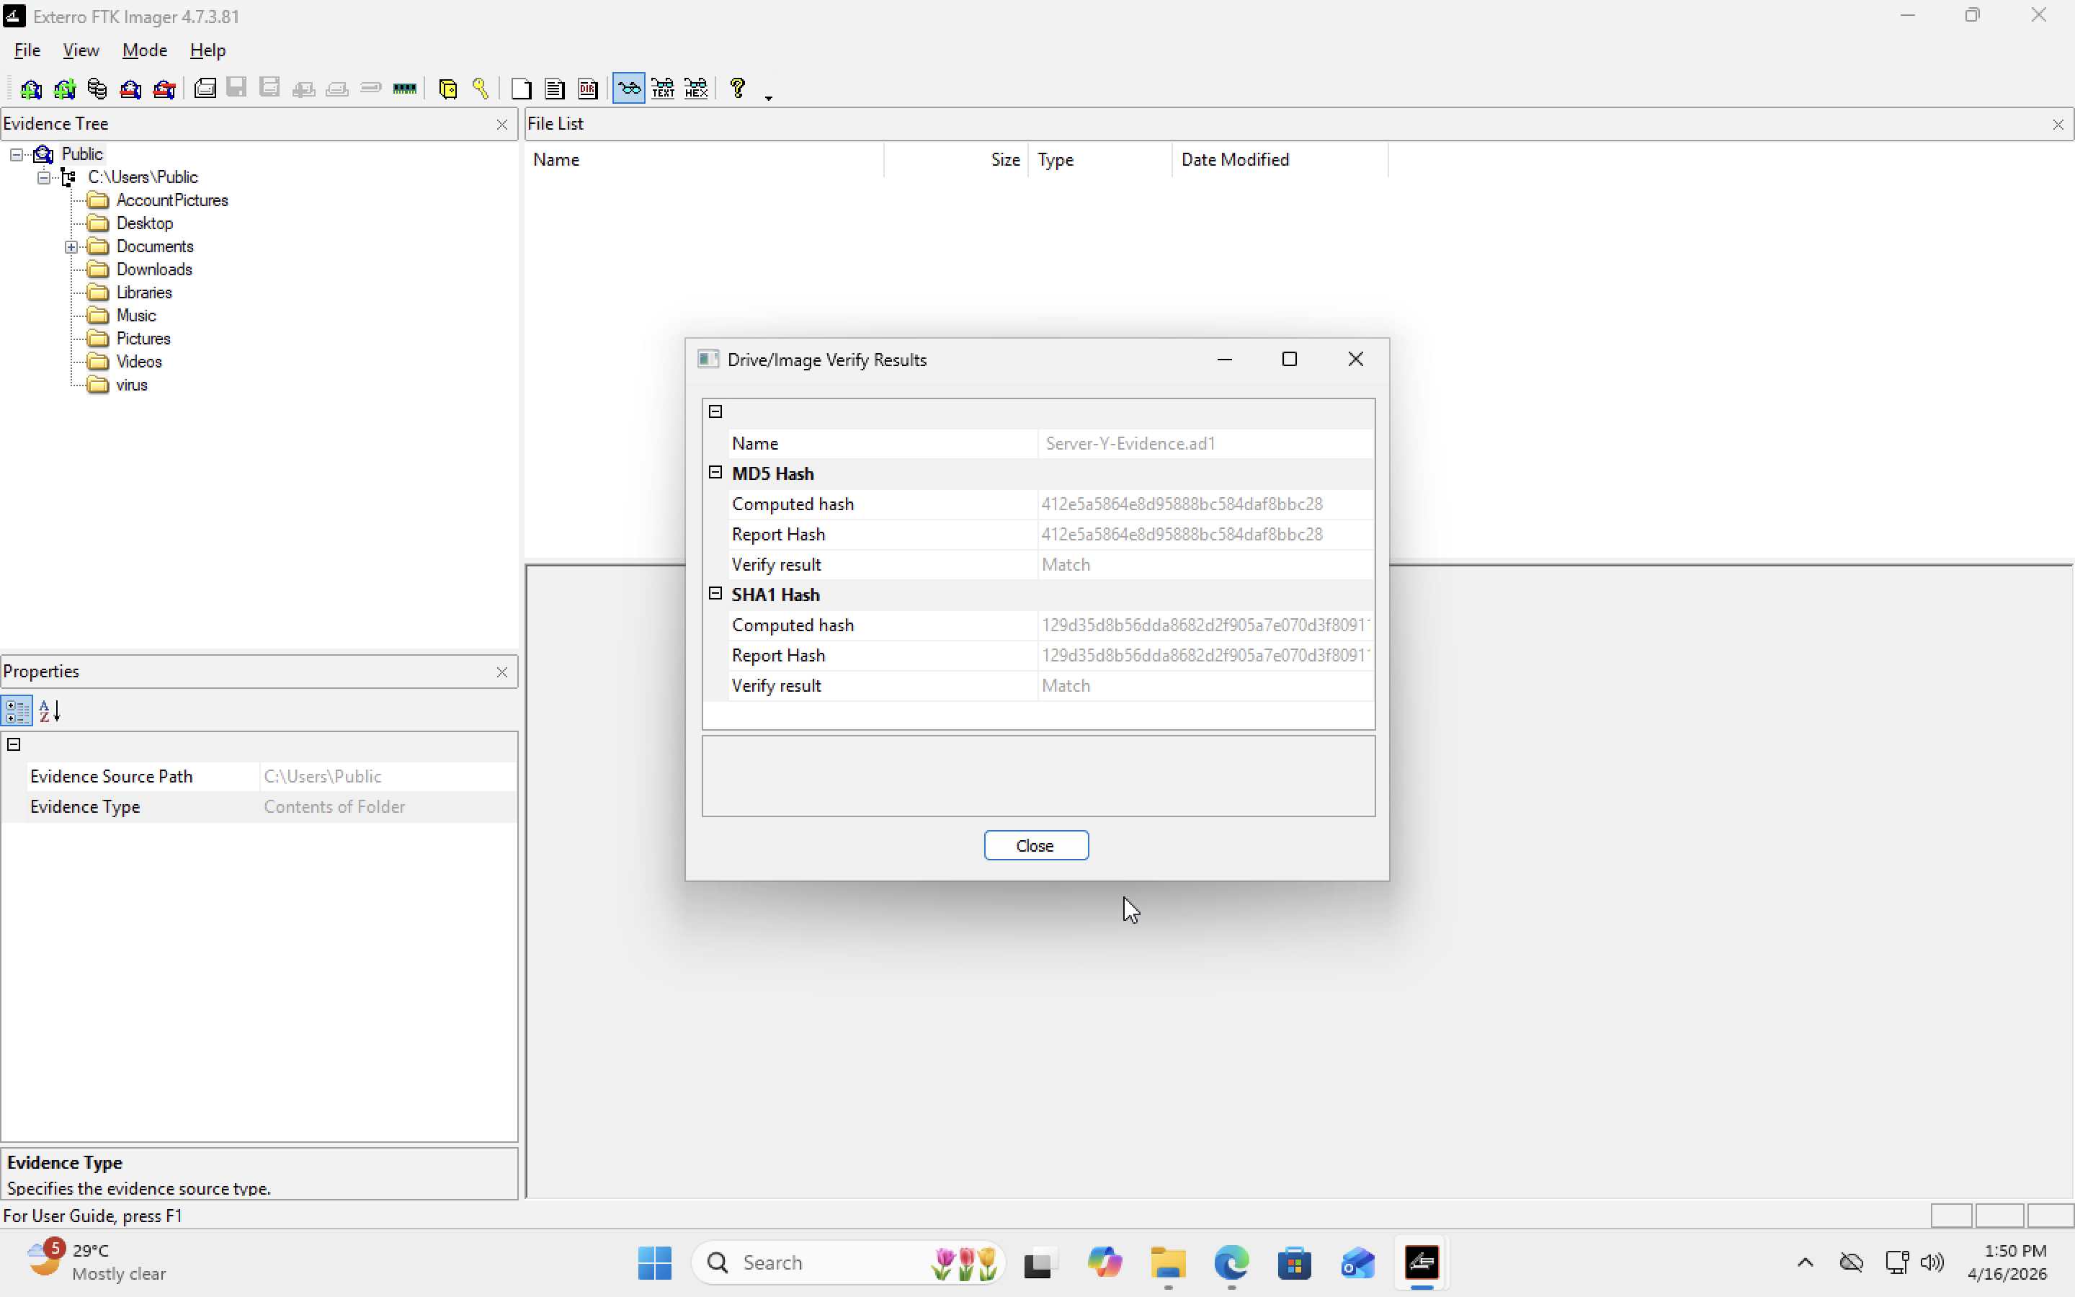

5. Integrity Verification (Manual Hash Check)

The imaging process was successful. Upon completion, the "Match" result in the verification window confirmed that our forensic image is a bit-for-bit perfect copy of the original data. We now have a secure, hashed evidence file (Server-Y-Evidence.ad1) that serves as our primary source for the upcoming investigation.

PowerShell Command Used:
Get-FileHash -Algorithm SHA256 .\Server-Y_Triage.zip

Resulting Output:
Algorithm: SHA256
Hash: f9c1d2e3b4a5069788796a5b4c3d2e1f0a1b2c3d4e5f6a7b8c9d0e1f2a3b4c5d
Path: C:\Forensics\Server-Y_Triage.zip

6. Analysis & Conclusion

The evidence collected shows no sign of tampering during the transfer from the Windows Client to the Ubuntu Server. The Netstat results confirmed the existence of the malicious process identified in Task 4, and the Triage Image has been preserved in the secure /var/tmp/velociraptor/uploads directory on the Ubuntu Manager for deep-dive analysis.

